**Why attend CA World 2014?**

This year, CA World content will be delivered in a totally new way. CA redesigned the content structure to be more focused and relevant to you, and it will be presented in seven Content Centers. CA also redesigned the layout of the Exhibition Center—so you can access sessions, demos, meetings and more in one centralized location on one floor. CA added a Meet the Expert area where you can speak with distinguished engineers, highly qualified developers and technical support teams for a full-spectrum view of CA solutions and industry expertise.

Sessions will feature solutions to help your business stay ahead in an application economy. CA experts will cover topics ranging from planning to DevOps to security, and you’ll have the opportunity to hear directly from CA customers, partners, thought leaders and many more. As a CA World ’14 attendee, you’ll participate in a “Cineplex” experience in our Exhibition Center, where you can attend sessions in state-of-the-art Cineplex theaters—all located on one floor in one centralized location.

**Simeio Solutions, Inc. will be presenting the following sessions and networking events:**

**Out of my “Minders” – the Energy Future Holdings Experience**

Presenter:  Loren Woeber, Director Information Security, Energy Future Holdings

Learn about how Energy Future Holdings (EFH), implemented the entire CA Identity & Access Management suite of “minder” products – CA Siteminder, Identity Minder, Control Minder, Authminder, and Governance Minder, in less than one year . The change management and marketing activities of this effort were key to the adoption by the business.

This presentation will be followed by Q&A session with CA, Simeio Solutions, service provider.

**Global Association of Investment Professionals Improves Operations and Productivity with IAM Delivered From the Cloud**

Presenter: Elaine Cheng, CIO CFA Institute

The service delivers CA Single Sign-On and CA Identity Manager from the Simeio Cloud Service to securely improve operations and productivity while providing improved services and a positive user experience to employees, partners and more than 500,000 candidates, members and other stakeholders in over 100 countries globally.

Learn how: The Simeio Cloud Service, backed by CA Technologies IAM solutions, supports CFA’s long-term business and technology strategy to provide services and infrastructure for optimum online engagement and transaction.

CFA achieved improvements and delivered a simple, automated user experience by turning to CA Technologies and Simeio Solutions for a seamless, scalable identity and access management (IAM) system that provides the foundation for a trusted IT environment.

**Exclusive Event-Invitation Only**

**Simeio Customer Appreciation**

**Aureole at Mandalay Bay**

<http://www.charliepalmer.com/aureole-las-vegas/>

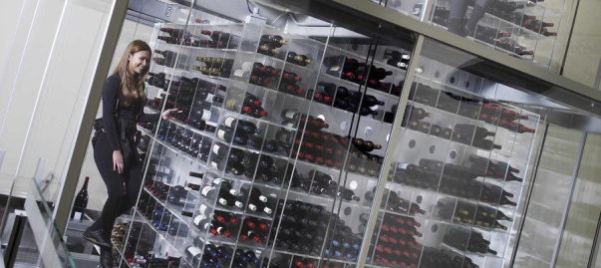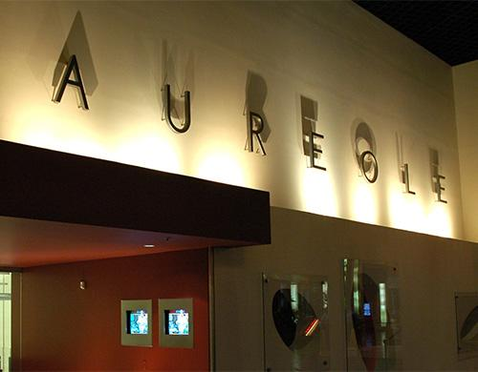

Tuesday, November 11, 2014 | 5:00-6:30 pm

Cocktails and hors d'oeuvres just before **CA World Event Night**

Our Friends and Customers are warmly invited

Send email if you'd like to receive an invitation